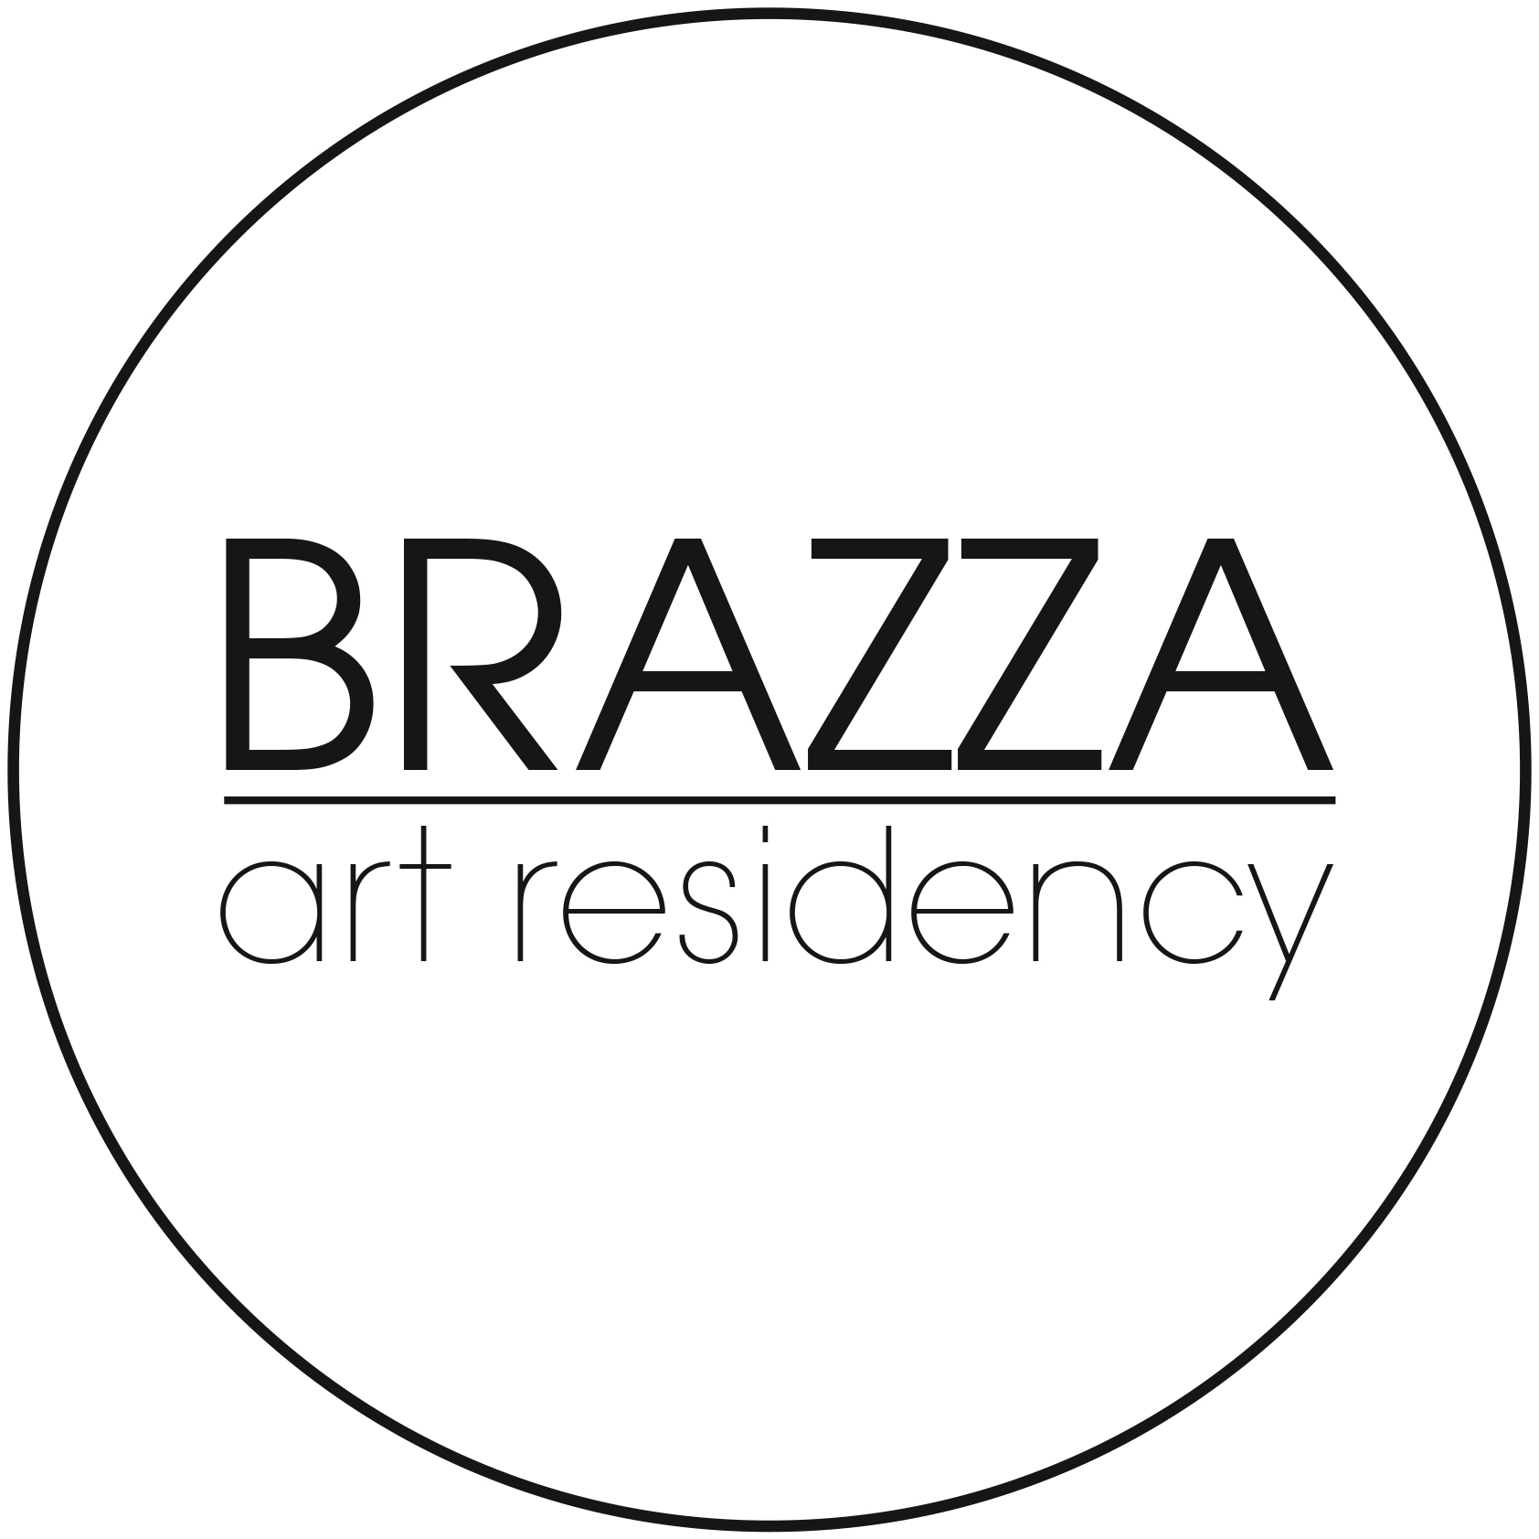
BRAZZA Art Residency 10 rue Aristide Briand
16120 Châteauneuf sur Charente
France

All inquiries by mail
brazzaresidency@gmail.com

APPLICATION FORM FOR ARTISTS
BRAZZA RESIDENCY PROGRAM

Eligibility

- Any nationality, gender, emerging as well as mid-career or established professional practitioners of any age can apply.
- Applicants must be conversant in English or French.

Type of Residency | Photo Workshop Art Residency Research Residency
Residency dates | From: To:  or  From: To:
Duration
(Art or research residency lasts between 2 weeks and 2 months)
(photo workshops minimum 6 nights)
Residing alone of with an assistant or partner?
If you wish to come with an assistant or a partner, insert his/her name, date of birth, address, contact details.

Personal Information

Name and Surname:

Date and place of Birth:

Nationality and gender:

Postal address:

Email address:

Telephone:

Website:

Instagram or facebook:

Title of Project:

Short Description of your Residency Project
(What do you intend to do? Why apply to the BRAZZA art residency?)

With this form, you will need to add :
- Portfolio (for artists and photographers) or your research project and affiliation (for researchers)
- Letter of intent
To send to : brazzaresidency@gmail.com

Additional Information

Funds
Are you applying for Funds? YES NO
Would you require a letter of invitation from BRAZZA Residency? YES NO

Insurance
We recommend that you have health, travel and liability insurance.

Visa
Participants from non-European countries may have to request a visa at the French embassy or consulate in their resident country. The applicant is responsible for all visa procedures.

Contact
For more information, please contact the Residence Coordinator, by email only.
brazzaresidency@gmail.com

Mailing list
The email address of every applicant will be automatically inserted in the BRAZZA residency mailing list and will receive the newsletter. Newsletters are published every 2 months.

What happens next?
After we have received your completed application form and any required documents, we will send you a verification by email.
We will contact you by email as soon as we have results of your application (within 3 weeks).

Rates
Rates differ according to the type of residency and according to type of boarding, please check the website for more information: brazzaresidency.wordpress.com

By submitting this application and residency proposal, you agree to the terms and conditions stated in this document. You declare that you are mentally and physically fit to complete the project that you have proposed.

Date: ______________ Place: ________________________________

Name:

Signature:

